The Outdoor Partnership Case Study – Adventure Group Lough Erne Expedition – May 2026

Background
The Adventure Group have been meeting regularly throughout the year for canoe and climbing sessions and were keen to have a weekend adventure. The group members have a range of mobilities and some are wheelchair users.
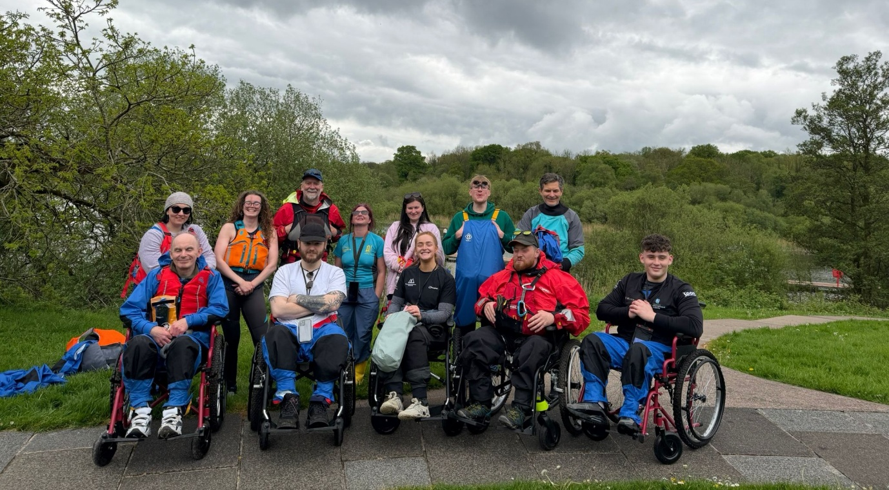

Activity
In May 2026 we partnered with Accessible Adventures Ireland to support 10 participants to take part in a Canoe Expedition on Lough Erne, Co Fermanagh. The trip was subsidised by The Outdoor Partnership South East NI. Paul from Accessible Adventure Ireland was able to cater to the needs of the group with different canoes and adapted seats so that everyone was comfortable and supported.
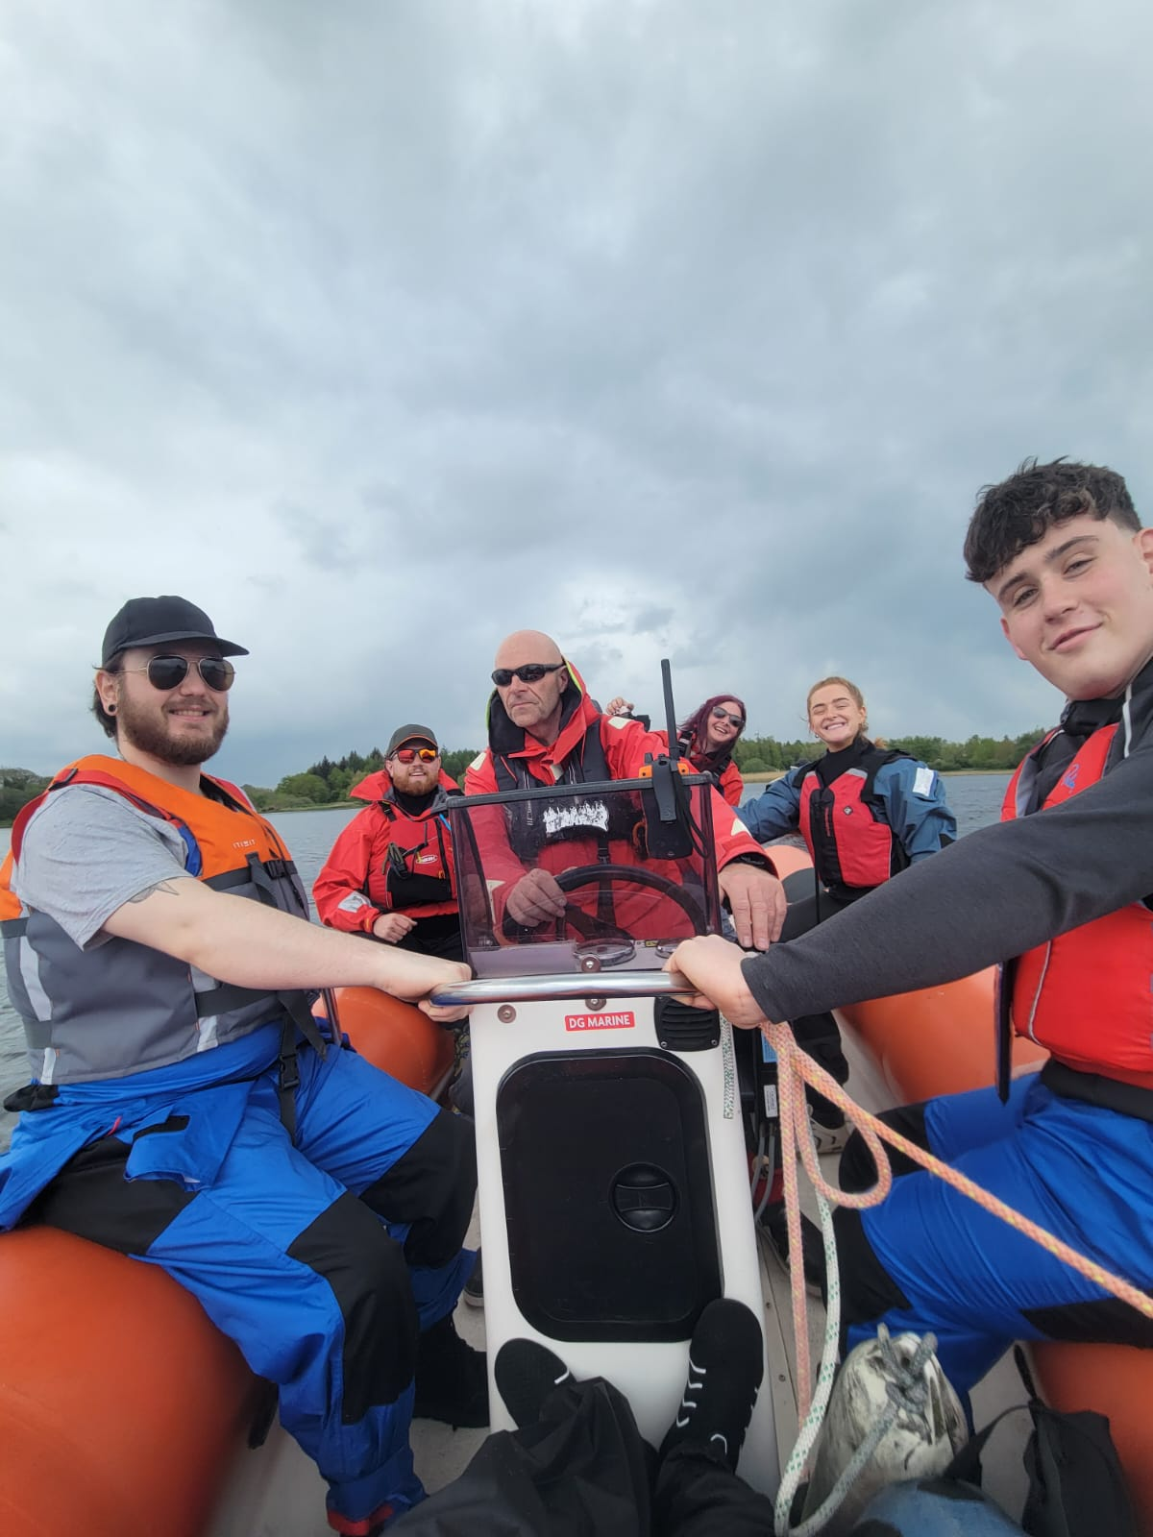
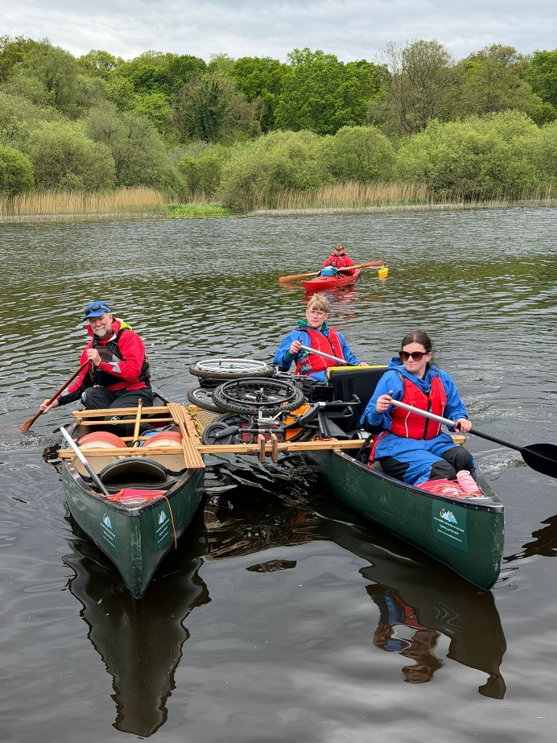
The groups stayed at The Share Centre from where they were able to easily access the Lough. On the Saturday they had an exhilarating trip on a rib to the starting point and enjoyed a day on the water with visits to the Lough’s many islands – this was followed by a breath work session to relax and unwind. On Sunday the group visited the Haire Krishna community on Lough Erne where they were invited to join a celebration which was a fascinating experience for all. Having off road wheelchairs supplied by Accessible Adventures Ireland meant that the group members were able to explore the Islands they visited during the trip making it a more accessible experience for all.

Feedback / Outcomes
The feedback from this trip was really positive with everyone keen to do more trips like this in the future.

“It’s not something I would have done/ felt capable of without the support of the organisers. Being in the fresh air, open water, one with nature”.

“I really enjoyed getting to meet new people and experience new things like kayaking as it was my first time doing anything like it!”

Group member Nathan shared some feedback in a video made about the event;

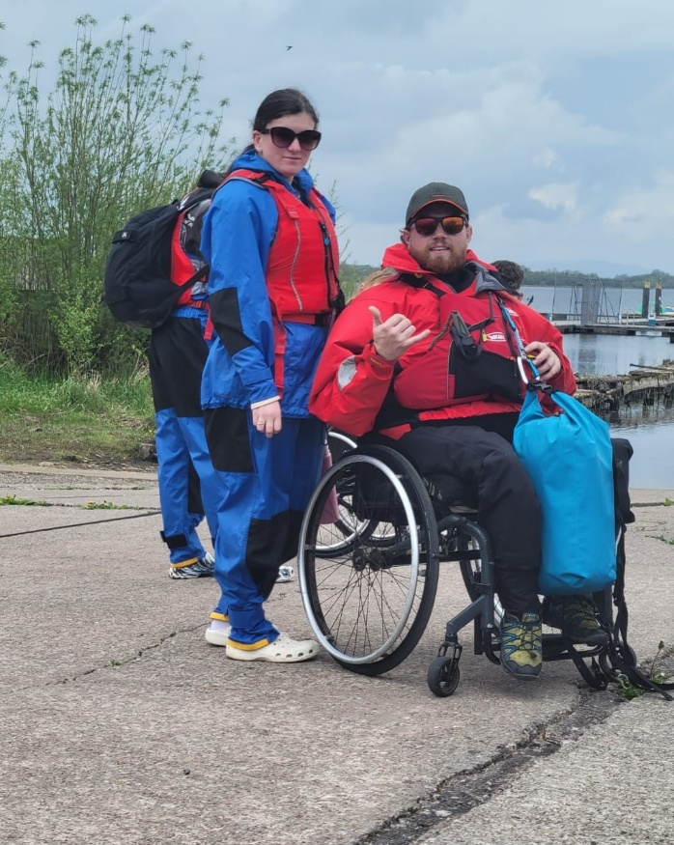
“Going out on travels with other folks in the same situation as yourself is a very humbling experience when you get to hear people’s stories and how they acquired their injuries and stuff. It’s a really nice bonding experience and creating new friendships for sure. The social aspect is incredible and words can’t describe the skill learning – I’ve started rolling my kayak which is something that I never thought I could do. It’s really good for my mental health being involved in events like this – the main thing for me is getting out on the water and having chats instead of having to text somebody. It’s that face to face contact that not everyone gets”.

Conclusion
These trips have further reinforced that events like this are really valuable for the participants to have a space for them to come together and take part in experiences which deliver opportunities to develop skills and have many benefits for the participants health and wellbeing. It is important to have regular sessions and events to continue the learning and social element of the group as well as giving new participants the opportunity to get involved.

