Bolster Wellbeing Project
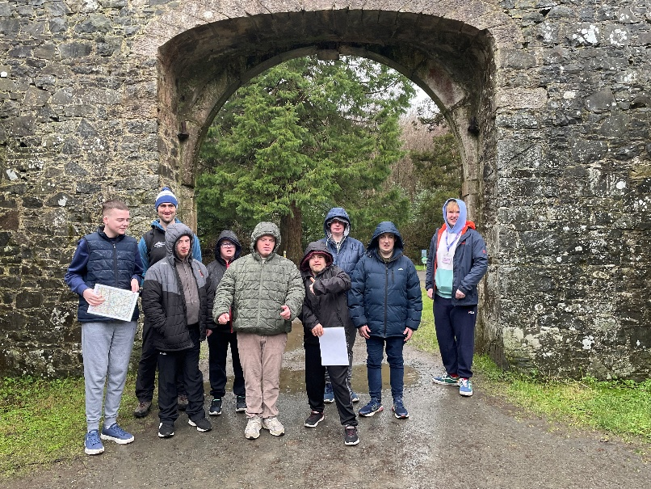
The Bolster Wellbeing Project was funded by the PHA through the Developing Healthy Communities Fund. The Bolster Community work with adults with Autism and learning disabilities and have identified that being involved in outdoor activities are really beneficial for their members so we put together an 8-week programme for them to participate in. Over the project we had 24 buddies from Bolster taking part in various outdoor activities.

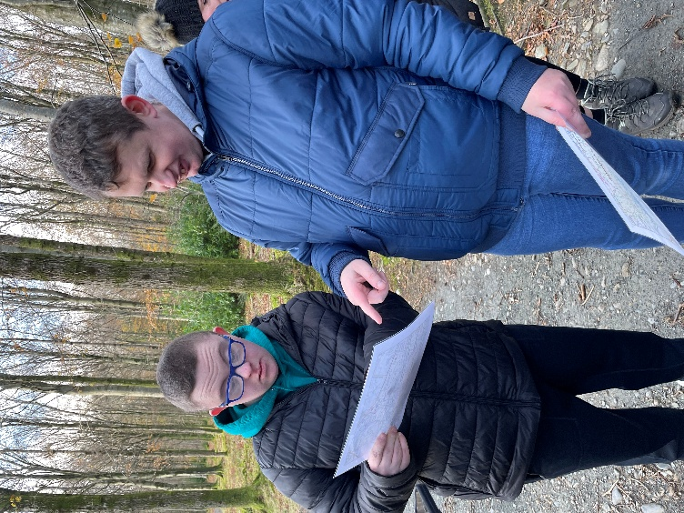
Activities included;
- Nature well-being and bushcraft at Hillsborough Castle and Gardens
- Climbing sessions at Boulder World in Belfast
- Watersports sessions at Moira Lakes
- Accessible cycling sessions at Craigavon Lakes
- Navigation sessions at Tollymore and Gosford Forest parks

Feedback / outcomes
- All participants completed feedback forms after participating in the programme – they all reported that through taking part in the activities they experienced an improvement in their well being
- Feedback from participant – “I had a ball! I loved doing the water sports. It puts me in good form!”

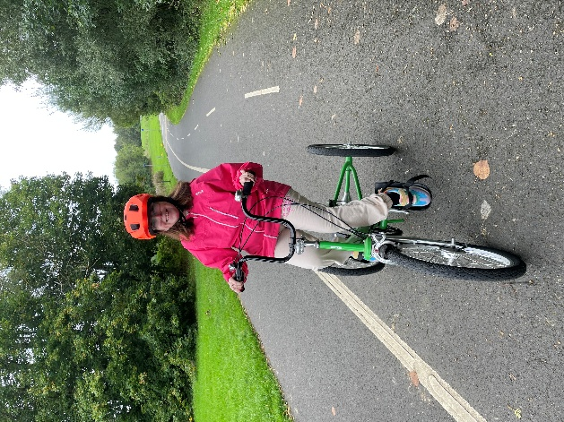
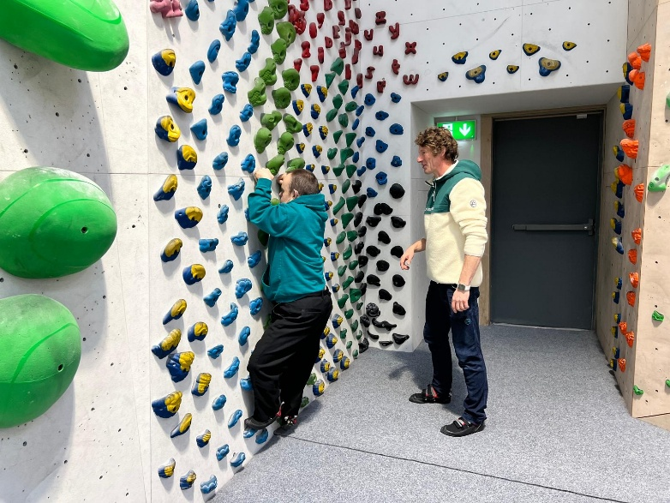

- Feedback from staff – “The buddies always look forward to every activity arranged by the Outdoor Partnership. Each activity has been carefully designed to be fully accessible for all their needs, ensuring that every buddy can participate comfortably and safely. At the same time, these experiences have allowed them to discover new places and interests—many of which they would never have encountered without the Outdoor Partnership supporting them. For many buddies, these activities were things they never imagined themselves doing. The opportunities have had a meaningful impact on the buddies’ overall wellbeing. Many have noticed improvements in their confidence, physical health, and willingness to explore new activities. Although trying something unfamiliar was often daunting, the support they received ensured they were able to participate with enthusiasm and determination. With every experience, they continue to build resilience, discover new strengths, and embrace new opportunities”.
Conclusion
- The group is very keen to take part in more outdoor activities. We will use the learning from this project to plan future programmes and seek funding for further opportunities.

