
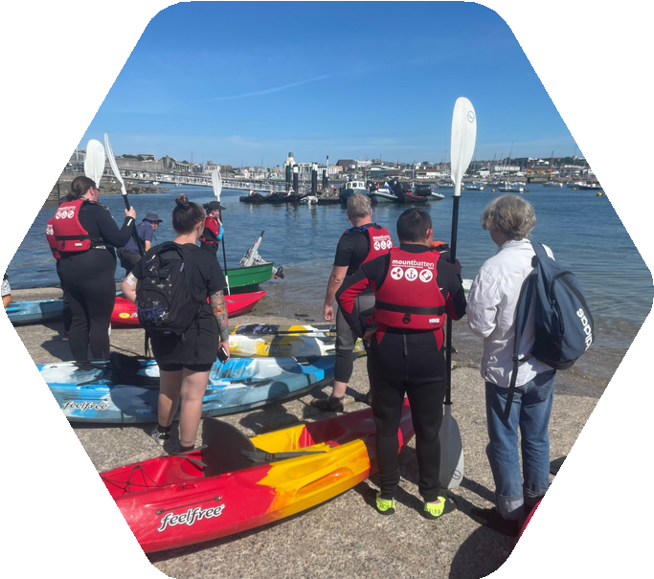

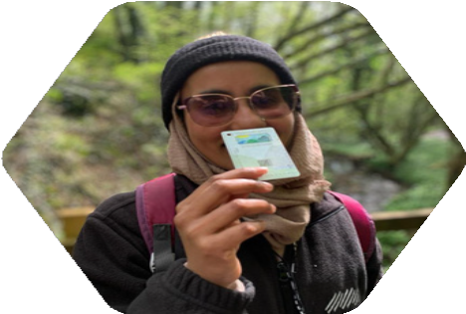

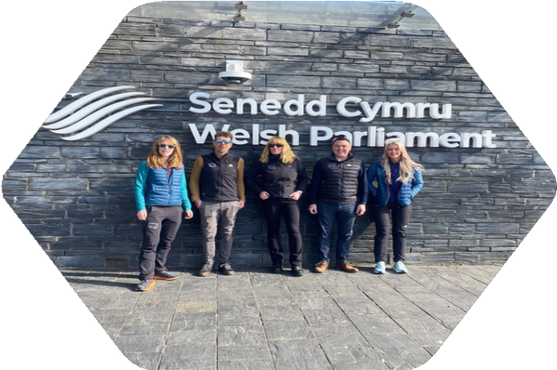
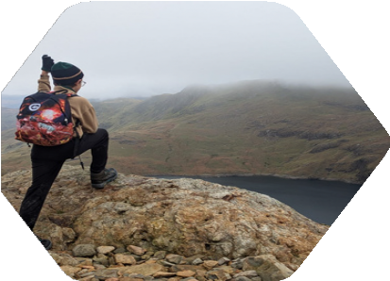

PRIVACY NOTICE
2026

Policy name: | Privacy Notice
Responsibility: | Human Resources
Approved by:
Date approved:
Date reviewed: | April 2026
Reviewed by: | Gareth Own, Dolen HR
Details of any changes:

.

The Outdoor Partnership Privacy Notice
The Outdoor Partnership is a registered charity (No. 1149280) and a limited company (No. 07705219).
We are committed to protecting your personal information and being transparent about how we use it.
If you have any questions about this notice or how we use your data, please contact:
info@outdoorpartnership.co.uk
- What this notice covers
This Privacy Notice explains:
- What personal data we collect
- How and why we use it
- Who we share it with
- How long we keep it
- Your rights under data protection law
- What information we collect
We may collect the following types of personal data when you register, book activities, volunteer, or engage with our programmes:
2.1 Basic personal information
- Name
- Date of birth
- Address
- Email address
- Telephone number
2.2 Booking and participation information
- Emergency contact details
- Attendance and activity records
- Experience and participation history
2.3 Health and safety information
- Relevant medical conditions
- Disabilities or additional needs
- Information required to ensure your safety during activities

2.4 Equality and monitoring information (optional)
- Gender
- Ethnicity
- Disability
- Employment status
- Welsh language ability
Providing equality information is optional and used for monitoring, reporting, and improving inclusivity.
3.0 How we collect your information
We collect information directly from you when you:
- Register on our system
- Book a course or activity
- Volunteer or engage with our programmes
- Contact us
We may also receive information from:
- Referral partners (e.g. schools, local authorities, community organisations)
- Funding partners (where relevant to programme eligibility)
4.0 How we use your information
We use your personal data to:
- Deliver activities and services you have registered for
- Ensure your safety and wellbeing during activities
- Communicate with you about your booking or participation
- Manage our programmes and services
- Meet safeguarding responsibilities
- Monitor participation and improve our services
- Meet funding and reporting requirements

5.0 Automated Processing and AI
The Outdoor Partnership may use approved digital tools, including AI-supported systems, to assist with administration, communication, safeguarding management, reporting, or ser vice delivery.
We do not make solely automated decisions which have a significant legal or similar effect on individuals without appropriate safeguards.
Any use of automated tools will be subject to appropriate oversight and data protection
Controls.
6.0 Our lawful basis for processing
We process your personal data under the following lawful bases:

Contract
To deliver activities and services you have registered for

Legal obligation
To meet safeguarding, health and safety, and regulatory requirements

Legitimate interests
To manage and improve our services and ensure effective delivery

Vital interests
To protect your safety in emergency situations
Special category data (sensitive information)
We may process sensitive personal data such as:
- Health information
- Disability information
- Equality monitoring data
We do this only where necessary and under the following conditions:
- To protect your safety during activities
- To meet safeguarding obligations
- For equality monitoring and reporting (where appropriate)
Providing equality data is voluntary and can be withdrawn at any time.
7.0 Sharing your information
We work with trusted third-party providers and partners to deliver activities.
Where necessary, we will share relevant personal data with these providers, including:
- Your name and contact details
- Emergency contact information
- Relevant health or safety information
This is to ensure activities are delivered safely and effectively.
We may also share data with:
- Safeguarding authorities (where required)
- Emergency services (in an emergency)
- Funding bodies (usually in anonymised or aggregated form)
All third-party providers are required to handle your data securely and in accordance with data protection law.
8.0 Marketing
We will only send you marketing communications (e.g. newsletters) if:
- You have opted in, or
- We are allowed to do so under applicable law
You can unsubscribe at any time.

9.0 International Transfers
Where personal data is stored or processed outside the UK, we will ensure appropriate safeguards are in place in accordance with UK data protection law.

10.0 How long we keep your information
We keep your personal data only as long as necessary, including:
- For delivering services
- For legal and safeguarding requirements
- For funding and audit purposes
Different types of data are kept for different periods in line with our Data Retention Policy.
You can request a copy by contacting us.
11.0 How we keep your information safe
We use appropriate technical and organisational measures to protect your data, including:
- Secure IT systems and password protection
- Restricted access to sensitive data
- Staff training on data protection
- Secure storage of paper records
- We recognise the importance of protecting children and vulnerable individuals’ personal data and apply additional safeguards where appropriate.

12.0 Your rights
You have the right to:
- Access your personal data
- Correct inaccurate information
- Request deletion (in certain circumstances)
- Restrict or object to processing
- Withdraw consent (where applicable)
To exercise your rights, contact:
info@outdoorpartnership.co.uk
We encourage individuals to contact us first so we can try to resolve any concerns directly before a complaint is raised with the ICO To complain to the Information Commissioner’s Office (ICO):
www.ico.org.uk

13.0 Updates to this notice
The latest version will always be available on our website

Policy updated:

Approved by:

Policy review: At least every three years. However, the policy will be reviewed earlier should there be legislative changes.

